**BME Capstone Design Project Weekly Progress Report**

**Project Title:** KK01: Design of extremely small satellite

**Student Name:** Bethany Santos, Ho Yin Samuel Yeung, Owais Nakhuda

**Reporting Week:** Oct15 - 19

**Project Manager of the Week:** Bethany Santos

**Tasks Outlined in Previous Progress Report:**

* Research the sprite femto satellite, the smallest satellite every sent into LEO (4.5 x 4.5 x 4.5 cm; 4g total mass)
* Research the starshot project, a exoplanet expedition plan related to the designer of the sprite femto satellite
* Determine Practical Satellite Design option for Communication and Geographical analysis
* Determine the basic system design of modern cubesats(how are measurements taken? How is communication setup to the ground station? What is the operating frequency?)

**Progress made in Reporting Week:**

* Sprite femto satellite was essentially a microcontroller with onboard solar cells, magnetometer, accelerometer and transmitter; the satellite was incapable of useful work
* The start shot program is an initiative to propel a small solar sail satellite to outside of the solar system. While the technology has been developed, it is still a work in progress and one of the lead advisors behind the project, Stephen Hawking, recently passed away. Currently there has been no public update to the project as of today.
* Found the lightest commercially available PCB called a copper clad, and contacted the supplier for weight specification. According to their information a 3.5cm x 3.5 cm copper clad sheet would weight.

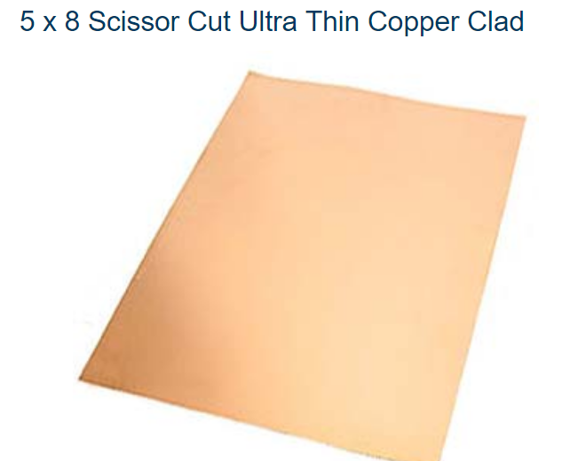

Other alternatives were then researched. Flexible PCB as substrates would provide a lighter alternative however there are not a lot of commercially available products for flexible PCB in the market let alone customizable one. To work around this, I looked at ways to chemically etch copper traces on to a plastic substrate in house. However, this may not be the most feasible option since flexible plastic PCB has a maximum bend radius before the circuit form cracks and disrupt electron flow. In addition, most plastic materials becomes brittle at low temperatures and have a high possibility of cracking. Other alternatives will be researched.

**NASA STRATEGIC PLAN 2018**

The CubeSat will have a higher possibility of being launched in space with NASA’s support if the CubeSat were able to benefit NASA with their current research. NASA provides a document called Strategic Plan which lists out their major goals for that year and coming future. NASA Strategic Plan 2018 focuses on 4 main theme: Discover, Explore, Develop, Enable. From these 4 themes, Discover’s strategic goal is describes as ‘to expand human knowledge through new scientific discoveries’. There are 2 strategic objectives under this goal, but Strategic Objective 1.2 is an objective that is the most relevant to biological payloads for the CubeSat and the project can help support.

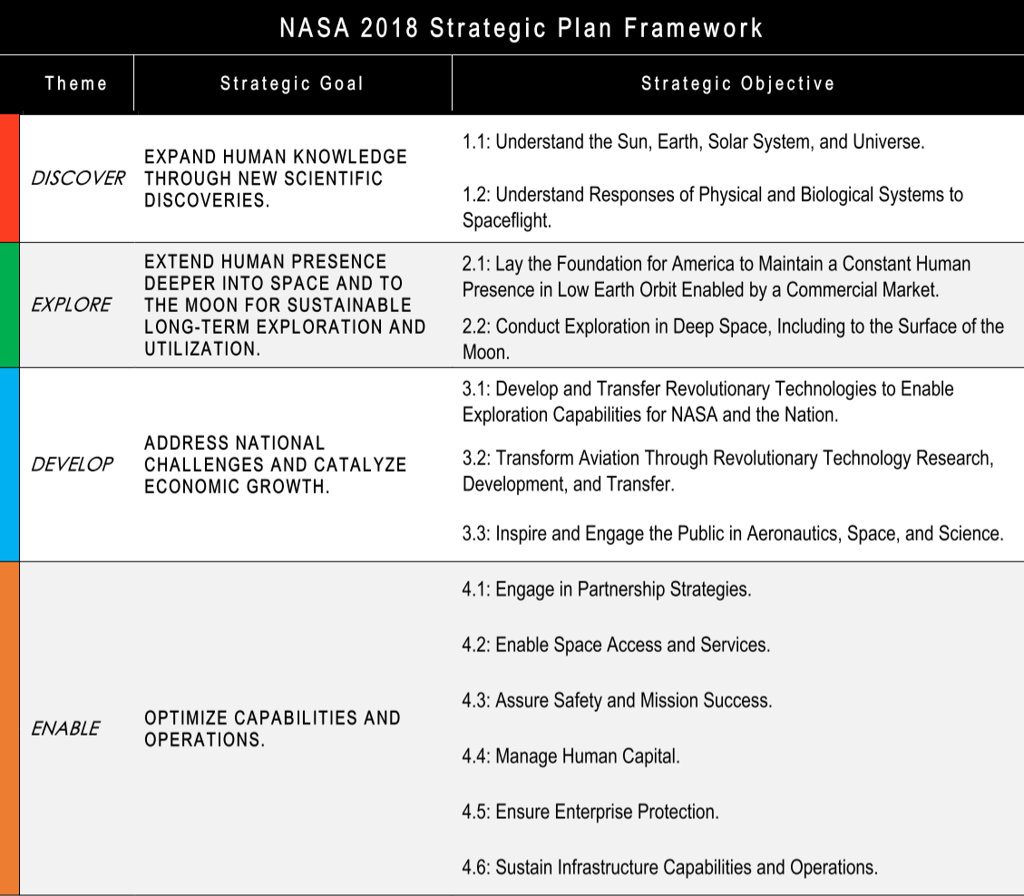

There are plans for longer missions in space, but as of right now, the maximum duration that a person is sent up to space is 6 months. However, in order to be able to send humans to space for longer periods, humans must first gain better understanding on how space stressors such as radiation and microgravity effects the human body and mentality. CubeSats are an effective solution to perform tests for this research since a cube sat can stay in LEO for many years.

Possible biological Payload is a lab that monitors how effects of microgravity and radiation affects biological characteristics of proteins and bones. Samples will be placed on a fluidics plate while sensors collect data to be downlinked to the ground station. In addition, different materials/chemicals/or substances that protect against radiation can be tested and monitor how well each one performs. The feasibility of this payload will be researched further.

**Tasks for Next Week:**

* Conduct more research into material sciences and biomedical payload

**Sources:**

<https://www.instructables.com/id/Acid-Etching-Printed-Circuit-Boards/>

<https://www.goldmine-elec-products.com/prodinfo.asp?number=G17455&utm_source=rb-community&utm_medium=forum&utm_campaign=lightest-pcb-solution>

https://www.nasa.gov/sites/default/files/atoms/files/nasa_2018_strategic_plan.pdf